BİLDİRİ BAŞLIĞI
ENGLISH TITLE

Name of the Author
Affiliation of the Author
e-mail Adress of the Author
Orcid Number

Özet: Çalışmanın özeti yer alacaktır.(Özet 10 punto)

Anahtar Kelimeler: Anahtar kelimeler virgülle ayrılarak yazılacaktır.

Abstract: A summary of the study will take place.(Summary 10 pt.)

Keywords: Keywords will be written separated by commas.

The title of the paper will be written in capital letters and 14 font size. In other titles only the first letter will be capitalized. Titles and subtitles can be used as necessary. Paragraphs should be justified, and paragraph indentation should not be given. First order titles should be 12 font size bold, and second order titles should be 11 font size bold. References will be given as author and date (e.g., Fox, 2014); or author, date, and page (e.g., Fox, 2014: 15) in the text. The main text should be prepared as a single file in .doc or .docx format with single line spacing, in ‘Arial’ font with 12 font size justified.

1. Introduction

General information, literature review (information on previous studies), scientific gap (necessity) and aim of the study should be written in the introduction part.

2. Method
The information and details of the materials and methods used in this section should be fluent and inclusive.
3. Results
The results obtained are given by a graph or table etc., important findings are expressed, a possible explanation, comparison with other studies or generalizations can be made in this section.
Images should be sized in proportion and have high resolution when placing them in the text. Figure explanations should be written in 10 font size. The line thickness of the tables should be as in the sample table. The texts in the table should be 9 font size and table names should be written in 9 font size centered on at the bottom part of the table. All tables must be created in a Word file or a vector-based program in accordance with the specified rules. Footnotes should be written in 8 font size.

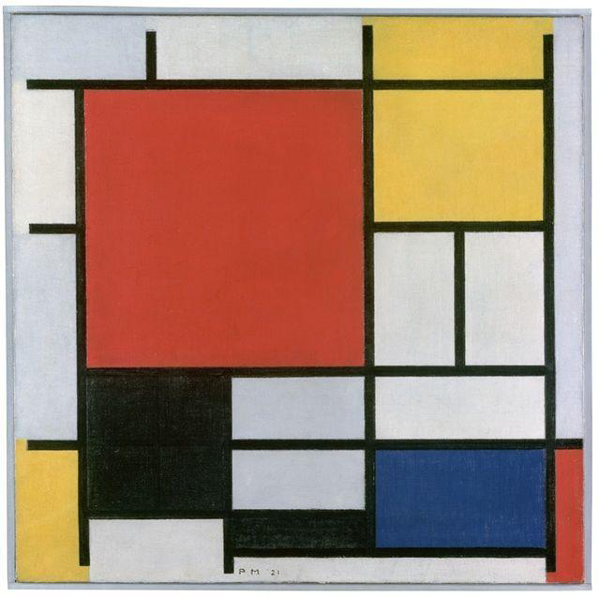

Figure 1. Piet Mondrian, Composition

Title 1 | Title 2 | Title 3

Table 1. Example (Title and Table should be centered)

4. Conclusions and Recommendations
Evaluations, comments, comparisons and generalizations related to the findings of the study can be given in the results and recommendations part. Recommendations can be in this part as well.
5. References
All references in the text should be placed at the end of the text in alphabetical order according to the surname of the authors in accordance with the following reference notation. References should be written in 10 font size.

Reference Notation Examples (APA 6)

Reference Examples for Books:

Daniels, K., Patterson, G. and Dunston, Y. (2014). The ultimate student teaching guide. 2nd ed.
Los Angeles: SAGE Publications, 145-151.

Aydın, N., Başar, M. & Coşkun, M. (2007). Finansal yönetim. Eskişehir: Aktüel.

Reference Examples for Articles in the Journals:

Dismuke, C. and Egede, L. (2015). The Impact of Cognitive, Social and Physical Limitations on
Income in Community Dwelling Adults With Chronic Medical and Mental Disorders. Global Journal of Health Science, 7(5), 183-195.

Arslan, A. (2009). Yapılandırmacı öğrenme yaklaşımı ve Türkçe öğretimi. Atatürk Üniversitesi
Sosyal Bilimler Enstitüsü Dergisi, 13(1). 143-154.

Ajzen, I. (1991). The theory of planned behavior. Organizational Behavior and Human Decision
Processes, 50(2), 179-211.

Notation Technique for Conference Papers:

Palmer, L., Gover, E. and Doublet, K. (2013). Advocating for Your Tech Program. In: National Conference for Technology Teachers. [online] New York: NCTT, 33-34. Available at: http://www.nctt.com/2013conference/advocatingforyourtechprogram/ (Accessed 11 Jan. 2014).

Reference Examples for Online Resources:

Walker, D. F. (1971). A naturalistic model for curriculum development. The School Review.
80(1), 51-65. http://www.jstor.org/stable/1084221?seq=1#page_ scan_tab_contents ,
erişim tarihi: 12 Ekim 2020

World Urbanization Prospects (2008). The 2011 Revision Population Database.
(http://esa.un.org/unup/) Accessed : 12 Dec. 2018

Reference Examples for Theses:

Bayraktar, N. (2006). Organ nakli – organ bağışı konusunda bilinçlendirme amacıyla interaktif
eğitim materyali hazırlanması. (Yayımlanmamış Yüksek Lisans Tezi). Gazi Üniversitesi
Eğitim Bilimleri Enstitüsü, Ankara.

Tunçel, M. (2013). Çocukluğun oyunlar ile analizi: Türkiye’ de önceki nesillerde büyüyen
çocukların oynadığı oyunlar ile 21. Yüzyılda büyüyen çocukların oynadığı oyunları
karşılaştıran etnolojik araştırma. (Yayımlanmamış Yüksek Lisans Tezi).

